Project Planning Phase

# Project Planning Template (Product Backlog, Sprint Planning, Stories, Story points)

|  |  |
| --- | --- |
| Date | 5 NOVEMBER 2022 |
| Team ID | PNT2022TMID43833 |
| Project Name | Classification of arrhythmia by using deep learning with 2-d ecg image spectral  representation |
| Maximum Marks | 8 Marks |

**Product Backlog, Sprint Schedule, and Estimation (4 Marks)**

Use the below template to create product backlog and sprint schedule

|  |  |  |  |  |  |  |
| --- | --- | --- | --- | --- | --- | --- |
| **Sprint** | **Functional**  **Requirement (Epic)** | **User Story**  **Number** | **User Story / Task** | **Story**  **Points** | **Priority** | **Team Members** |
| Sprint-1 | Registration | USN-1 | As a user, I can register for the application by entering my email, password, and confirming my  password. | 5 | High | Navaneetha krishnan,Vigneshwaran,Arun Mani,Sethu Ram |
| Sprint-1 |  | USN-2 | As a user, I will receive confirmation email once I have registered for the application | 5 | High | Navaneetha krishnan,Vigneshwaran,Arun Mani,Sethu Ram |
| Sprint-1 |  | USN-3 | As a user, I can register for the application through Facebook | 5 | Low | Navaneetha krishnan,Vigneshwaran,Arun Mani,Sethu Ram |
| Sprint-1 |  | USN-4 | As a user, I can register for the  application through Gmail | 5 | Medium | Navaneetha krishnan,Vigneshwaran,Arun Mani,Sethu Ram |
| Sprint-2 | Login | USN-5 | As a user, I can log into the application by entering email &  password | 5 | High | Navaneetha krishnan,Vigneshwaran,Arun Mani,Sethu Ram |
| Sprint-2 | Dashboard | USN-6 | As a web user grid format which make it easy to see | 5 | Low | Navaneetha krishnan,Vigneshwaran,Arun Mani,Sethu Ram |
| Sprint-2 | Registration | USN-1 | As a user, I can register for the application by entering my email, password, and confirming my  password. | 5 | Medium | Navaneetha krishnan,Vigneshwaran,Arun Mani,Sethu Ram |

|  |  |  |  |  |  |  |
| --- | --- | --- | --- | --- | --- | --- |
| **Sprint** | **Functional**  **Requirement (Epic)** | **User Story**  **Number** | **User Story / Task** | **Story**  **Points** | **Priority** | **Team Members** |
| Sprint-2 | Conformation | USN-2 | As a user, I will receive confirmation email once I have  registered for the application | 5 | High | Navaneetha krishnan,Vigneshwaran,Arun Mani,Sethu Ram |
|  |  | USN-3 | As a user, I can register for the application through Facebook | 5 | Low | Navaneetha krishnan,Vigneshwaran,Arun Mani,Sethu Ram |
|  |  | USN-4 | As a user, I can register for the  application through Gmail | 5 | Medium | Navaneetha krishnan,Vigneshwaran,Arun Mani,Sethu Ram |
| Sprint-3 | Login | USN-5 | As a user, I can log into the  application by entering email & password | 5 | High | Navaneetha krishnan,Vigneshwaran,Arun Mani,Sethu Ram |
| Sprint-3 | Dashboard | USN-2 | Team of representatives offering customer support | 5 | Low | Navaneetha krishnan,Vigneshwaran,Arun Mani,Sethu Ram |
| Sprint-3 | Responsibilities | USN-3 | Revolve customer compliants | 5 | Medium | Navaneetha krishnan,Vigneshwaran,Arun Mani,Sethu Ram |
| Sprint-4 | User registration | USN-1 | Registration to the respective hospital through the Hospitals website by entering your  name,age, phone number and address | 5 | High | Navaneetha krishnan,Vigneshwaran,Arun Mani,Sethu Ram |
| Sprint-4 | Registration options | USN-2 | As a staff, I can register for the  application through the hospital's official website | 5 | Low | Navaneetha krishnan,Vigneshwaran,Arun Mani,Sethu Ram |
| Sprint-4 | Login | USN-3 | As a Healthcare staff, I can log in to the application by entering the right credentials like phone  number and password | 5 | Medium | Navaneetha krishnan,Vigneshwaran,Arun Mani,Sethu Ram |
| Sprint-4 | Dashboard | USN-4 | Enables healthcare professionals to access important patient statistics in real-time | 5 | High | Navaneetha krishnan,Vigneshwaran,Arun Mani,Sethu Ram |

**Project Tracker, Velocity & Burndown Chart: (4 Marks)**

|  |  |  |  |  |  |  |
| --- | --- | --- | --- | --- | --- | --- |
| **Sprint** | **Total Story Points** | **Duration** | **Sprint Start Date** | **Sprint End Date (Planned)** | **Story Points**  **Completed (as on Planned End Date)** | **Sprint Release Date (Actual)** |
| Sprint-1 | 20 | 4 Days | 31 OCT 2022 | 3 NOVEMBER 2022 |  |  |
| Sprint-2 | 20 | 5 Days | 4 NOV 2022 | 8 NOVEMBER 2022 |  |  |
| Sprint-3 | 20 | 5 Days | 9 NOV 2022 | 13 NOVEMBER 2022 |  |  |
| Sprint-4 | 20 | 6 Days | 14 NOV 2022 | 19 NOVEMBER 2022 |  |  |

**-Velocity:**

Imagine we have a 10-day sprint duration, and the velocity of the team is 20 (points per sprint). Let’s calculate the team’s average velocity (AV) per iteration unit (story points per day)

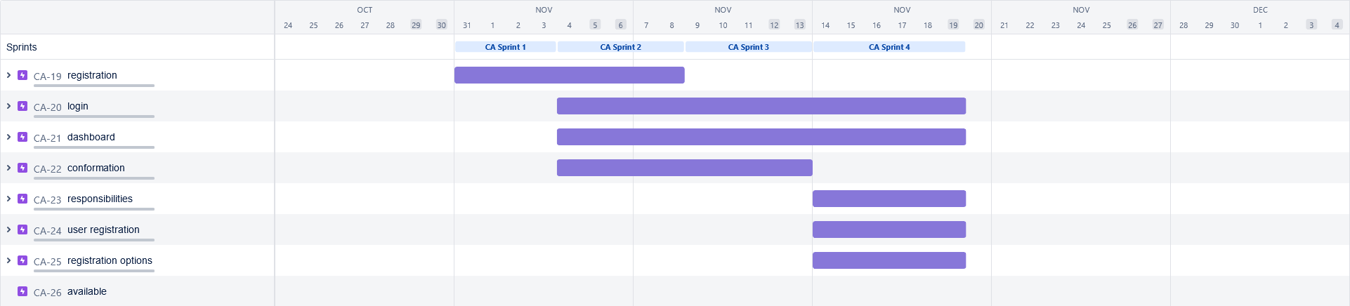

**BurndownChart:**

A burn down chart is a graphical representation of work left to do versus time. It is often used in agile [software development](https://www.visual-paradigm.com/scrum/what-is-agile-software-development/) methodologies such as [Scrum](https://www.visual-paradigm.com/scrum/scrum-in-3-minutes/). However, burn down charts can be applied to any project containing measurable progress over time.

